**Figure 1**

*Violin plots of R2 for every model on ACT and ECLSKschool datasets*

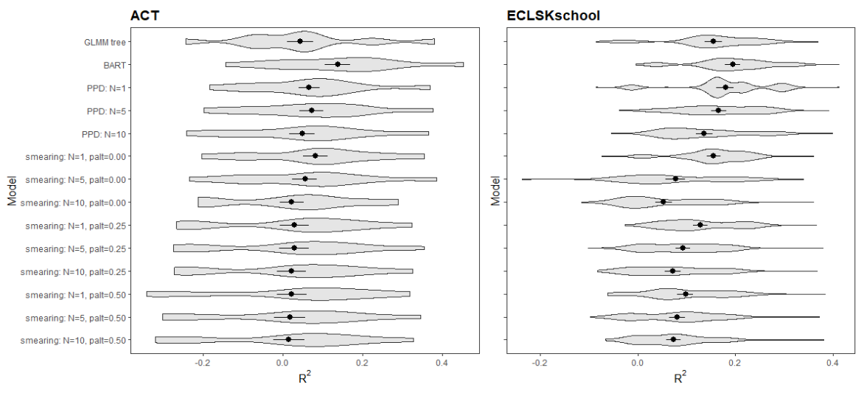 *Note: R2* over tentimes 10-CV (100 folds). Black dots indicate mean *R2* and black lines indicate one standard deviation in each direction from the dots.

**Figure 3**

*Effect of N on R2 and tree size for every dataset*

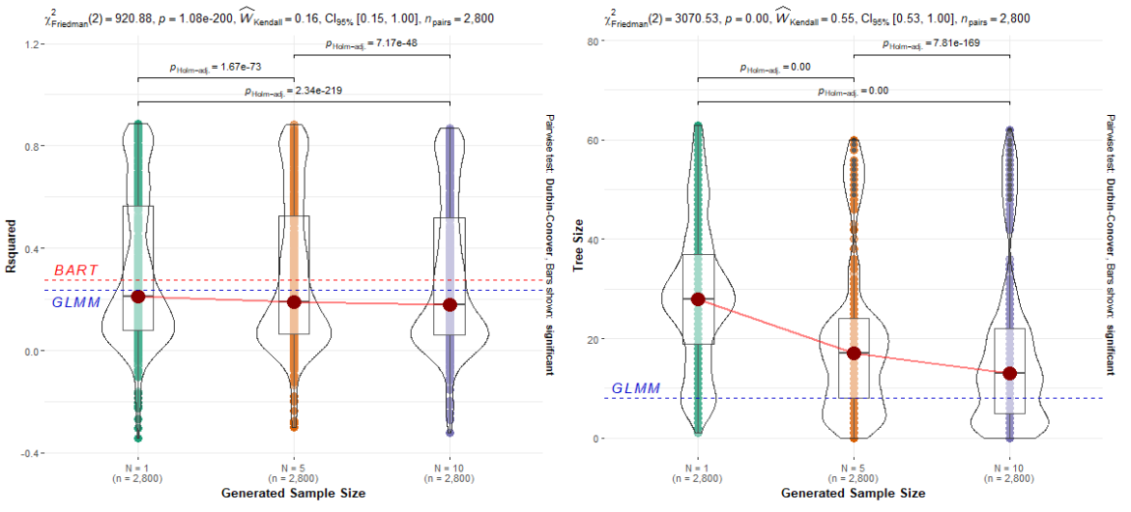

*Note: R2 (left) and tree size (right)* over tentimes 10-CV (100 folds) for all BA GLMM models on all seven datasets. *Blue dotted line marked by “GLMM” marks the median R2 or tree size of GLMM models. Red dotted line marked by “BART” marks the median R2 of BART model. Red dots connected by red solid line indicate median R2 or tree size.*

**Figure 4**

*Effect of palt on R2 and tree size for every dataset*

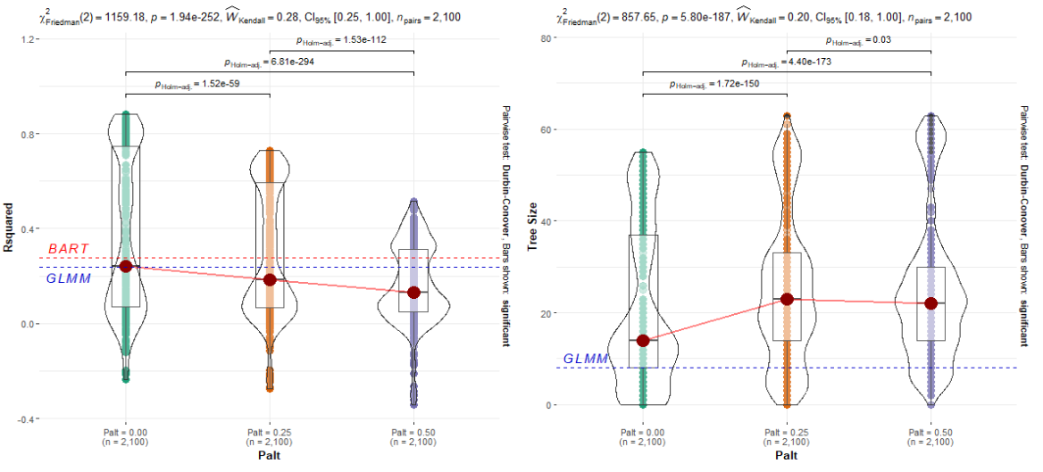

*Note: R2 (left) and tree size (right)* over tentimes 10-CV (100 folds) for all BA GLMM models on all seven datasets. *Blue dotted line marked by “GLMM” marks the median R2 or tree size of GLMM models. Red dotted line marked by “BART” marks the median R2 of BART model. Red dots connected by red solid line indicate median R2 or tree size.*

**Figure 2**

*Mean R2 of GLMM, M-BART, and most accurate BA GLMM models on ACT and ECLSKscience datasets.*

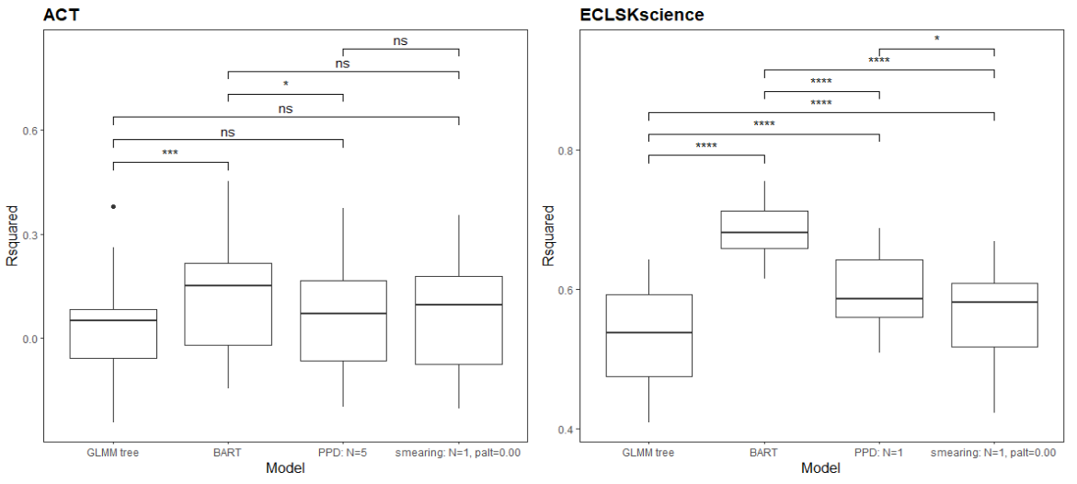

*Note: 10 times 10-CV results in R2 per model. Bars over boxplots indicate results of Tukey tests. ns: not significant, *: p < .05, **: p < .01, **: p < .01, ***: p < .001, ****: p < .0001.*

*:*

**Table Appendix 1**

*Mean R2 and standard deviation for every model on every dataset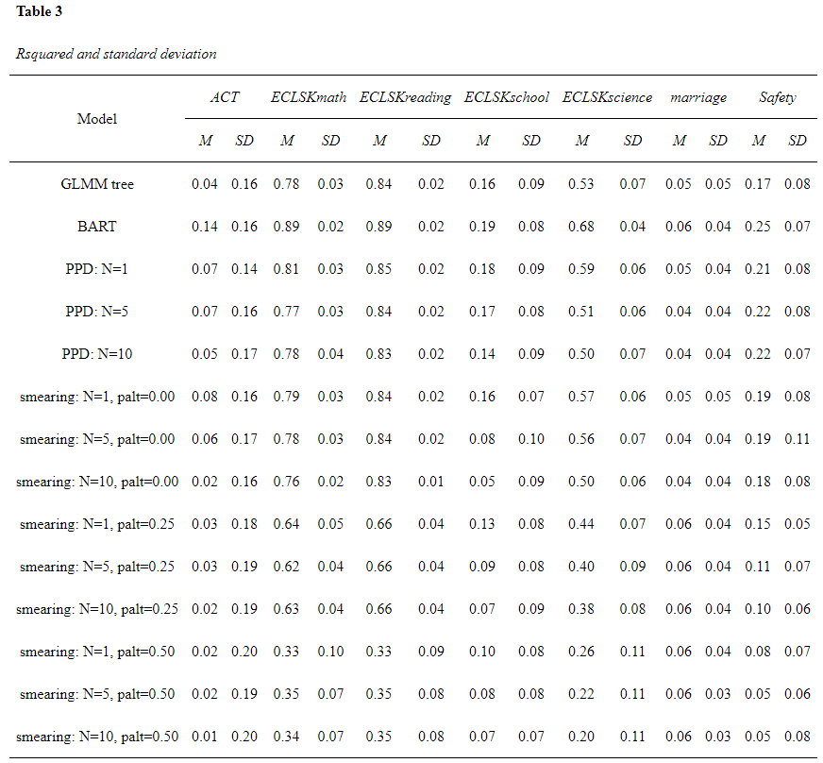 Note: M* is mean *R2* over tentimes 10-CV (100 folds). *SD* is standard deviation.

**Table Appendix 2**

*Mean tree size and standard deviation for every model on every dataset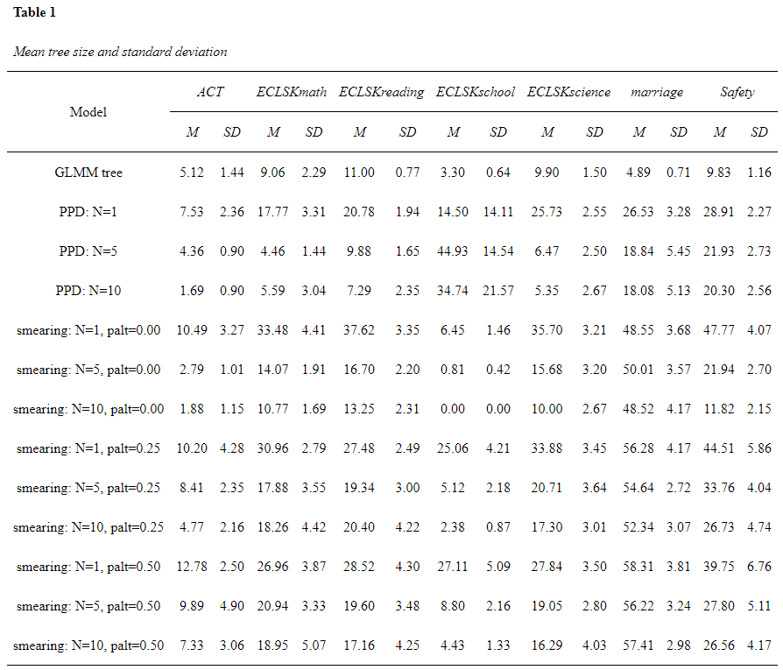 Note: M* is mean tree sizeover tentimes 10-CV (100 folds). *SD* is standard deviation.

**Figure Appendix 3**

*Effect of palt on tree size for every model grouped by N*

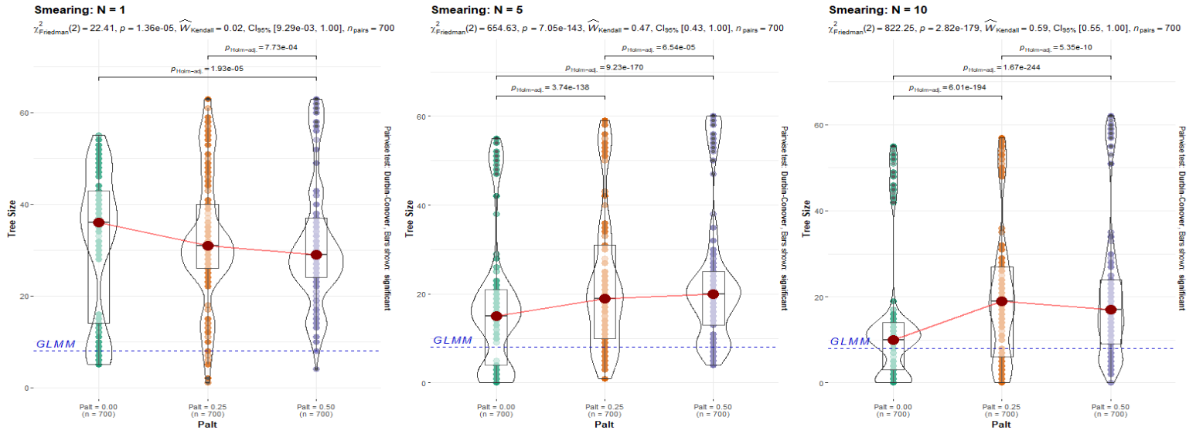

*Note: Blue dotted line marked by “GLMM” marks the median tree size of GLMM model. Red dots connected by red solid line indicate median tree size.*